1. Introduction

As a field of study, Management Information System (MIS) has generally been characterized as the study of the use of computing and communication technology. An MIS System collects, organizes and analyzes data from external and internal sources of organization and provides timely, accurate, useful information for managerial decision making process. MIS thus becomes a facilitating system for managers in developing decisions related to planning, directing, organizing and controlling.
As the process of analyzing and processing huge chunks of data, in every possible way to extract the relevant information, is tedious and time-consuming, computers are redefining this system with high efficiency and reliability. This system, while accelerating the pace of data analysis, still lags behind while talking about the data processing. This problem could be tackled with the automated system of software processing of the data by querying the millions of records in a matter of seconds. But this transformation doesn’t happen overnight. It’s slow but sure to happen.

DATA
(Input)

PROCESSING
(Computer Software)
INFORMATION
(Output)

Figure 1 Transformation of raw data to information (simple)

The use of database software in processing data has umpteenth of advantages. The database is secure, reliable and efficient in managing a large chunk of data.

2. Present Context
The ‘Intelligent Network’ department, in short IN, is a division dedicated to manage the intelligent service calls. In an intelligent network (IN), the logic for controlling telecommunications services migrates from traditional switching points to computer-based, service independent platforms. The services offered by the IN, Sundhara are Prepaid Calling Card (PCC), PSTN Credit Limit (PCL), Advanced Free Phone (AFS), Home Country Direct (HCD) and Universal Access Number (UAN), though UAN is in experimental phase now. The records of these calls are filled in raw text file with the fields separated by pipe ( | ). Each field has its own significance, for e.g. Calling Subscriber Number, Called Subscriber Number, Service Key, Translated Party Number, Duration of calls, Start and Stop times, to name a few. The present scenario of the IN is that these text files are analyzed manually with the tedious extraction of information from these fields. These processes have to be repeated at times of necessity or while making the monthly report, to facilitate the MIS system.
What actually does the raw file contain then? Well, it contains everything that’s needed for defining the call records like Service Key, Calling Party Number, Called Party Number, Translated Party Number, Specific Charge Part, Start Date and Time, Stop Date and Time, Duration, Call Cost , Charge Class, Fee Count, to name a few. For instance, service key 200 stands for PCC while 216 stands for PCL. Another important parameter is the charge class which denotes the call type, whether it’s a local call or STD (STDA or STDB) or Trans-border, etc. For instance, Charge Class ‘1’ denotes a local call while charge class ‘2’ stands for STD A while ‘11’ for Zonal Mobile.

3. What actually aMIS does?
The aMIS is basically a part of the MIS facilitating software which can be used to present the raw data in text file into a viewable form. It first updates its database for the daily records and its particulars into the table which is then used to query the records to fill the tables meant for each services i.e. 5 services. The tables, for instance, pcc200708, pcl200603, etc. are formed for each month and the update process from these daily formed temporary tables are done for each day of the month unless the next month starts with the fresh table. The figure depicting this process is shown below.

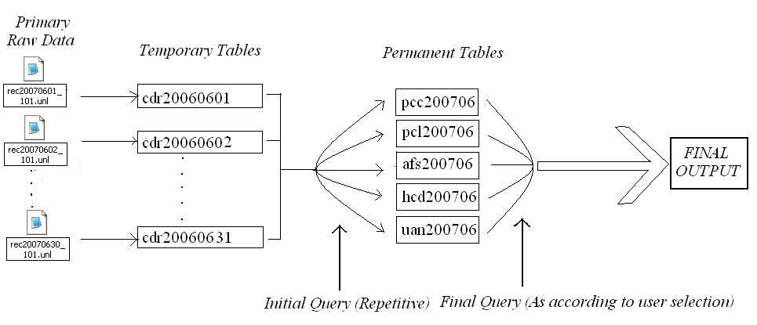
Figure 2 Transformation of raw data to information (detail)

The raw files were to be obtained from the database server into the prescribed folder in the local computer in which the application is to be run. The field containing one important piece of information is separated by pipe (‘|‘). These are first loaded into the temporary table meant to be deleted after entering all its records into the services table, which are permanent tables. These are pronounced ‘permanent’ in the sense that these tables can be retained and queried even after years of its creation.
The report can be viewed monthly, yearly according to some criteria, charge-class-wise or day-wise. The monthly view is done in terms of Charge class-wise manner. The total records of each Charge Class type along with its total cost incurred and total duration of talk is shown in the Month Report. Listing all the available charge class makes it possible to view the total calls, cost incurred or revenue generated and the total time in which the subscriber was busy. The figure below shows the screenshot of the month query for the month of July automatically exported to Excel.

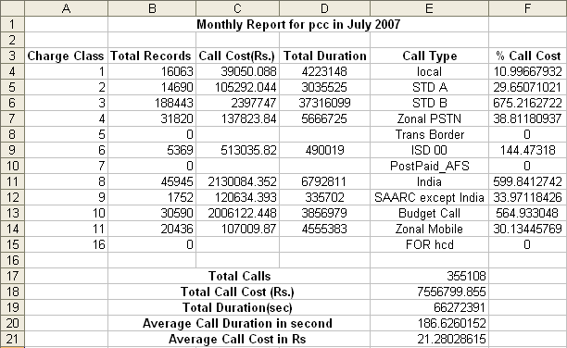
Figure 3 Example of monthly report in Excel format

This monthly view feature is directly used to submit the report to the MIS Department for the revenue analysis.
The annual view of the program works only when all the data for the complete year are available. It then shows the bar chart diagram for the total calls and total revenue (or cost from client side) for the whole year.
The summary report has two categories – class wise and day wise. The Charge-class is the important category to view the report for. For e.g. the IN Department wants to know how much call or the revenues have been incurred within the given range of date limits in the specified charge class. The call can be Local Call, STD A, STD B, Zonal PSTN, Trans Border, ISD 00, PostPaid_AFS, India, SAARC except India, Budget Call, and Zonal Mobile, to name the present categories. But this categorization is subject to modification, change or addition. So, these charge classes are stored into the separate table ‘ChargeClass’.
In day wise summary, it generates the data for the range of dates specified. This helps in keeping record of the daily traffic. The variation of the daily traffic can then be studied and the reason behind high or low traffic analyzed. The figure below shows the snapshot of the daily summary report from June 15 to July 7.
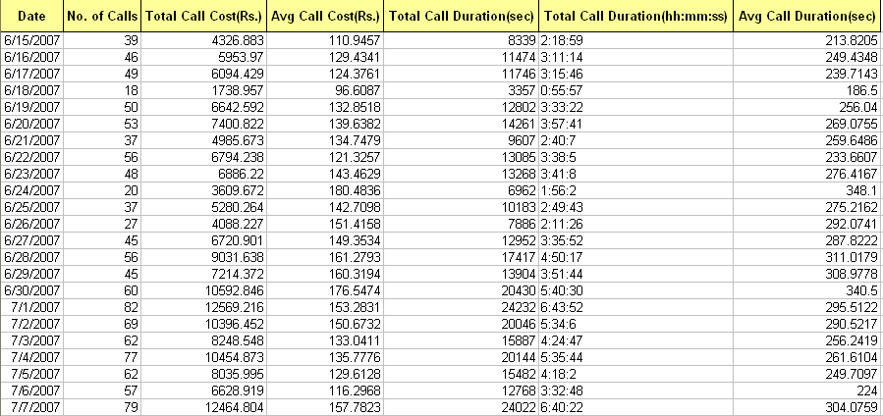
Figure 4 Daily report in Excel format

The above discussion primarily focuses on the summary type of reports which says about the totality of calls recorded, grand revenue collected and the duration of the talk time. But what if the client wants to view a ‘Detail’ figure in a table satisfying some criteria and with the field he wants. Well, ‘Normal Report’ is the answer. It lists all the particulars of the criteria matching record calls either in a excel view or the grid form view. The search for those records having Calling Party Number starting from ‘0142459’ is done with the listed fields if the user enters the calling party number criterion as ‘0142459’. This is shown in Figure in the grid form view.
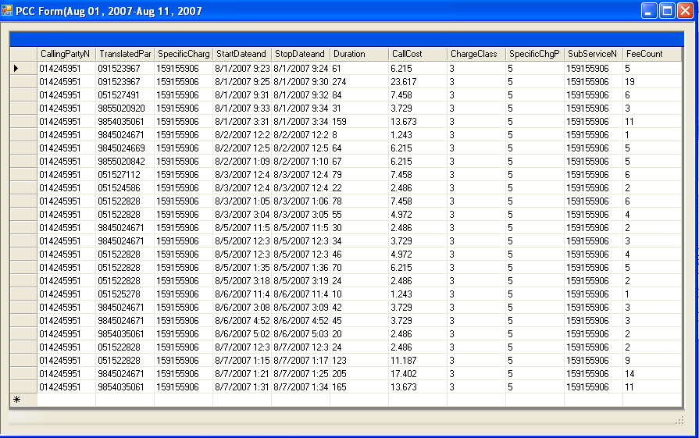
Figure 5 Normal Report in grid form
4. Features of aMIS
This software has been developed so that two different category of user can query the information. The first is the “admin” level and the next is the “guest” level. The admin level has got the privilege to see the query results in various formats like ‘Grid Form View’ and ‘Excel’ format. The ‘Grid Form View’ is uneditable while its Excel counterpart is editable. So, with a view that the guest or the normal user who likes to query the data shouldn’t be allowed to modify the query content as that can have a disastrous situation in report presentation, this software only lets the guest user to see the ‘Grid Form View’.
Diagrammatic or pictorial representation is useful in comparison and analyzing process. It is eye catchy and its study is easier than the tabular form. Excel has many options regarding this feature, out of which we use pie chart and bar chart. The ‘Annual Report’ is generally done with the bar charts for each English months for the last 12 months while for others pie-chart is generally preferred. The figure shows the pie-chart that has been created for the month of July 2007 whose table is given in figure. This figure instantaneously shows that the revenue is generated maximum for the ‘STD B’ type of calls which is the STD calls beyond 50m.
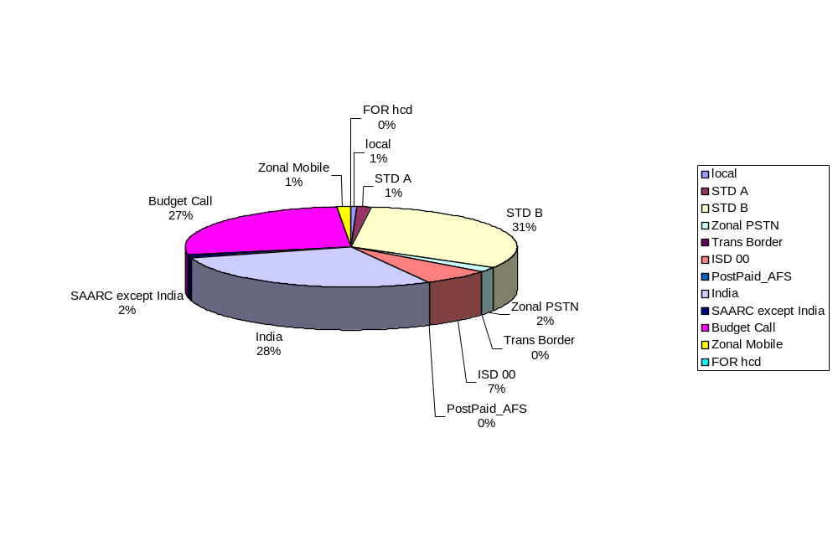
Figure 6 Pie Chart view of charge class wise calls made

The ‘Excel View’ has been thoroughly revised and much simplified. As such, the user has only to click buttons to present the MIS Report to the MIS Department. This feature is implemented with the help of .COM objects of the excel which can be accessed with the .NET. These object-oriented concepts are vital in performing the desired operation as we normally do within the Excel environment. The same knowledge of Excel Application, Excel Workbook, Excel Sheets, Ranges, etc. applies while accessing the properties or methods of .COM objects. When more than one service is selected, the services are given in different sheets. But for the ‘Grid Form View’, separate windows forms are generated for each service.

5. Tools and Techniques used for aMIS
For the overall management of the software, the Visual C#.NET is used for various reasons. The first and the foremost is its IDE for which the Microsoft has spent enough labor, time and money. The features provided with C# inside .NET IDE are countless. The C#.NET 2005 version has been used to utilize its most recent features. For the database part, ‘MySQL’ is used because of its open source and easy availability features. The excel automation is done by using .COM objects of the excel.

6. Importance of aMIS
The need for some type of automating software was obvious from the fact that the raw data files were to be filtered each day. These data are much sensitive in analysis of the present and future condition of the IN Department. If done manually, the chances for the erroneous manipulation of data is inevitable. So, these data must be extracted and put for processing by the use of efficient software and/or the database(s). The database, after filling the data from the raw sources, gives umpteenth of in-built functions and query methods to produce the result in the desired way. Moreover, the database acting as a facilitator between the raw data and final output assists in debugging the overall process in a stepwise fashion.

7. Problems Faced
The main problems faced during the software development are listed below:
- Automating Excel with C#.NET
- Querying two or more tables simultaneously
- No “Save” option for the form.

8. Future Enhancements
The following enhancements could be done for the ‘aMIS’
- Make the forms in the ‘savable’ format and making them ‘navigable’.
- Daily import the raw files automatically from the server and update the database.
9. Conclusion
We had a hard work in the development of the project. In a limited time, we tried our best to utilize most of the query algorithm of ‘MySQL’ through .NET environment. The knowledge of database and excel was crucial for implementing these techniques in ‘C#.NET’ platform.

References
• Professional C#, 3rd Edition
By Simon Robinson, Christian Nagel, Jay Glynn, Morgan Skinner, Karli Watson, Bill Evjen
• SAMS Teach Yourself C#.NET in 24 days.
• Oreilly C#.Net Programming, 2nd Edition
By Jesse Liberty
- Reference Manual for the MySQL Version 5.0.9-beta
- ‘MSDN’ websites for Excel Automation

